# PIZZA SALES SQL QUERIES

1. KPI’S
2. Total revenue

SELECT SUM(total_price) as Total_revenue

FROM pizza_sales

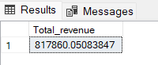

1. **Average Order Value**

SELECT (SUM(total_price) / COUNT(DISTINCT order_id)) AS Avg_Order_Value FROM pizza_sales

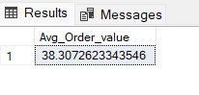

1. Total Pizza’s sold

SELECT SUM(quantity) AS Total_Pizza_sold FROM pizza_sales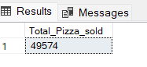

**4. Total Orders**

SELECT COUNT(DISTINCT order_id) AS Total_Orders FROM pizza_sales

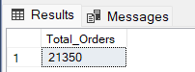

**5. Average Pizzas Per Order**

SELECT CAST(CAST(SUM(quantity) AS DECIMAL(10,2)) /

CAST(COUNT(DISTINCT order_id) AS DECIMAL(10,2)) AS DECIMAL(10,2))

AS Avg_Pizzas_per_order

FROM pizza_sales

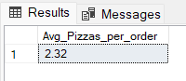

**B. Daily Trend for Total Orders**SELECT DATENAME(DW, order_date) AS order_day, COUNT(DISTINCT order_id) AS total_orders

FROM pizza_sales

GROUP BY DATENAME(DW, order_date)

***Output:***

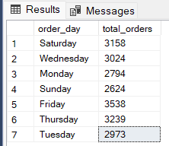

**C. Monthly Trend for Orders**

select DATENAME(MONTH, order_date) as Month_Name, COUNT(DISTINCT order_id) as Total_Orders

from pizza_sales

GROUP BY DATENAME(MONTH, order_date)

***Output:***

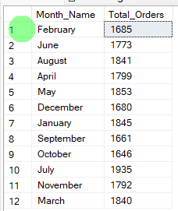

**D. % of Sales by Pizza Category**

SELECT pizza_category, CAST(SUM(total_price) AS DECIMAL(10,2)) as total_revenue,

CAST(SUM(total_price) * 100 / (SELECT SUM(total_price) from pizza_sales) AS DECIMAL(10,2)) AS PCT

FROM pizza_sales

GROUP BY pizza_category

***Output***

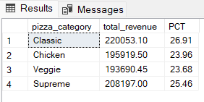

**E. % of Sales by Pizza Size**

SELECT pizza_size, CAST(SUM(total_price) AS DECIMAL(10,2)) as total_revenue,

CAST(SUM(total_price) * 100 / (SELECT SUM(total_price) from pizza_sales) AS DECIMAL(10,2)) AS PCT

FROM pizza_sales

GROUP BY pizza_size

ORDER BY pizza_size

***Output***

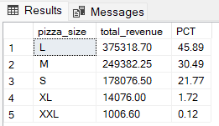

**F. Total Pizzas Sold by Pizza Category**

SELECT pizza_category, SUM(quantity) as Total_Quantity_Sold

FROM pizza_sales

WHERE MONTH(order_date) = 2

GROUP BY pizza_category

ORDER BY Total_Quantity_Sold DESC

***Output***

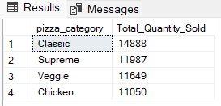

**G. Top 5 Pizzas by Revenue**

SELECT Top 5 pizza_name, SUM(total_price) AS Total_Revenue

FROM pizza_sales

GROUP BY pizza_name

ORDER BY Total_Revenue DESC

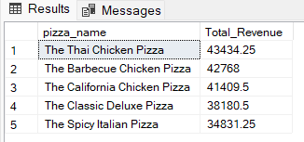

**H. Bottom 5 Pizzas by Revenue**

SELECT Top 5 pizza_name, SUM(total_price) AS Total_Revenue

FROM pizza_sales

GROUP BY pizza_name

ORDER BY Total_Revenue ASC

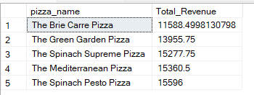

**I. Top 5 Pizzas by Quantity**

SELECT Top 5 pizza_name, SUM(quantity) AS Total_Pizza_Sold

FROM pizza_sales

GROUP BY pizza_name

ORDER BY Total_Pizza_Sold DESC

***Output***

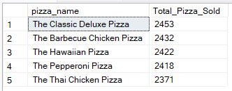

**J. Bottom 5 Pizzas by Quantity**

SELECT TOP 5 pizza_name, SUM(quantity) AS Total_Pizza_Sold

FROM pizza_sales

GROUP BY pizza_name

ORDER BY Total_Pizza_Sold ASC

***Output***

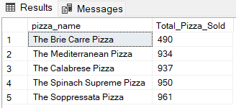

**K. Top 5 Pizzas by Total Orders**

SELECT Top 5 pizza_name, COUNT(DISTINCT order_id) AS Total_Orders

FROM pizza_sales

GROUP BY pizza_name

ORDER BY Total_Orders DESC

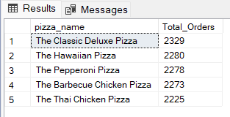

**L. Borrom 5 Pizzas by Total Orders**

SELECT Top 5 pizza_name, COUNT(DISTINCT order_id) AS Total_Orders

FROM pizza_sales

GROUP BY pizza_name

ORDER BY Total_Orders ASC

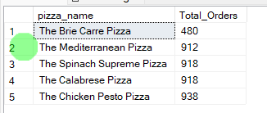

***NOTE***

If you want to apply the pizza_category or pizza_size filters to the above queries you can use WHERE clause. Follow some of below examples

SELECT Top 5 pizza_name, COUNT(DISTINCT order_id) AS Total_Orders

FROM pizza_sales

WHERE pizza_category = 'Classic'

GROUP BY pizza_name

ORDER BY Total_Orders ASC